17.58: The heat lost by the sample is the heat gained by the calorimeter and water, and the heat capacity of the sample is

=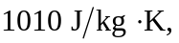

or 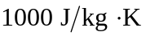to the two figures to which the temperature change is known.

